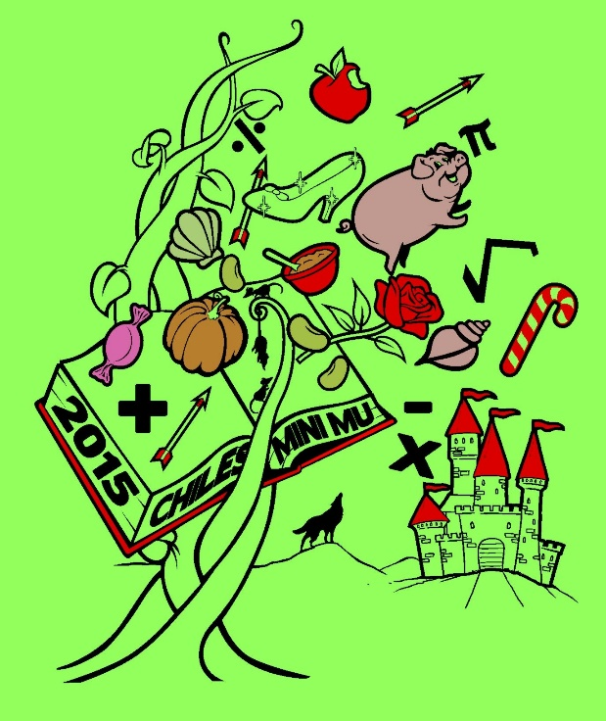

**2015**

**CHILES MINI MU**

**12 December 2015**

**Lawton Chiles High School**

**Hosted by Chiles Mu Alpha**

**Theta**

**ELEMENTARY**

**SESSION 1**

**JACK and the BEANSTALK**

Once upon a time, in a castle high up in the sky, lived a lovely couple of giants. The wife was constantly bossed around by her husband. She never got a break! But one day, a human boy snuck into her home and changed her life forever. She wrote this test retelling his tale.

This is the Jack and the Beanstalk Elementary test. This is a 30 question multiple-choice test. If none of the answer choices are correct, select (E) NOTA (none of the above). 5 points is awarded for a right answer, 1 point for a blank answer, and 0 for a wrong answer. Remember, you have 60 minutes to complete this test. Have a “fairy” good time!

